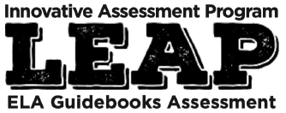
Session 4:
Understanding Item Types on the Innovative Assessment
Synthesis

Participant Guide

Objectives
Using pp. 11-12, 20-33 of the IAP Score Report Guidance document, participants will…
- Engage in a scoring activity for the Synthesis essay

Let’s Set the Context
Record all of the nouns that you see in the IAP writing prompt.
Abstract Nouns/Thematic Topics

Let’s Set the Context: Text Access Document
What do you notice about the texts chosen for the writing prompt?
What connections do these texts have to the big ideas of the writing prompt?

Let’s Set the Context

Text | Must Use New Text Choose 2 Unit Texts | Notes
The Heretic’s Daughter | New Text: Required
The Witch of Blackbird Pond | Choice Text
“Choices” | Choice Text
“Identity” | Choice Text
“The Road Not Taken” | Choice Text
Let’s Set the Context: Reader’s Circle for Literary Texts

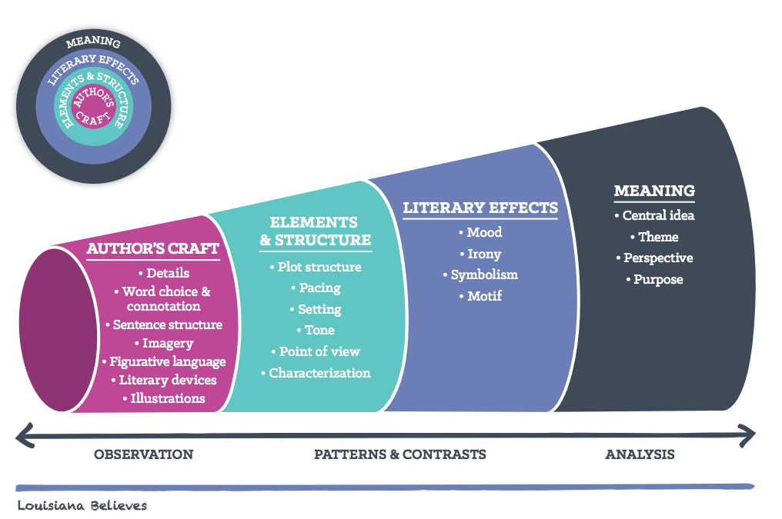

Reflection and Closing
What did you learn from the scoring activity?

