
Session 3:
Understanding Item Types on the Innovative Assessment
Selected-Response and Constructed Response

Participant Guide

Objectives
Participants will
- use pp. 16-17 of the IAP Assessment Guide for Grades 5-8 Guidebooks Operational Tests to increase their knowledge of sample selected response and constructed response test items; and
- use pp. 11-19 of the IAP Score Report Guidance document to engage in a scoring activity for the constructed response sample item.

Let’s Set the Context
Record all of the nouns that you see in the Let’s Set the Context unit statement.
Abstract Nouns/Thematic Topics

Let’s Set the Context: Text Access Document
The following texts are in The Witch of Blackbird Pond Guidebook unit.

The Witch of Blackbird Pond
To access the texts for this unit:
- Purchase bundles of the purchased texts through the Text Portal;
- Purchase The Witch of Blackbird Pond Unit Reader for each student to access the additional texts for the unit, and
- Download and print The Witch of Blackbird Pond Student Materials for each student. Read the Reading Guide to learn how these texts were selected.
Text Title | Excerpt | Author/Source | Use in Unit | Access Type
The Witch of Blackbird Pond |  | Elizabeth George Speare | Student copy (Anchor Text) | Text Portal
“Choices” |  | Nikki Giovanni | Student copy | The Witch of Blackbird Pond Unit Reader
“Identity” |  | Julio Noboa Polanco | Assessment (Student copy) | The Witch of Blackbird Pond Unit Reader
“Puritans” |  | Michael Kaufman (The New Book of Knowledge, Grolier Online) | Student copy | The Witch of Blackbird Pond Unit Reader
“The Road Not Taken” |  | Robert Frost | Student copy | The Witch of Blackbird Pond Student Materials
History of the United States of America | “Puritan Laws and Character” | Henry William Elson (transcribed by Kathy Leigh) | Student copy | The Witch of Blackbird Pond Student Materials
Strange Phenomena of New England in the 17th Century including the “Salem Witchcraft, 1692,” from the writing of Cotton Mather, New York, 1846 | Title and last page of Confession of Salem Jurors | The Library of Congress | Student copy | The Witch of Blackbird Pond Student Materials
Salem Witch Trials | “The Story of the Witch Hunt” (Video) | Discovery Education | Read aloud | Digital access
Note: There are different allowances for text use and printing based on the permission status of each text. Written permission of the copyright owner(s) and/or other rights holders is required for distribution, reproduction, or other use of protected items beyond that allowed by fair use or other statutory exemptions. Responsibility for securing any necessary permission rests with the user.

Let’s Set the Context: Text Access Document
What do you notice about the balance between literary and informational texts?
How does this text set look similar to some of the ELA Guidebooks units?
What are the connections between the nouns that were
identified in the previous activity and the texts in this set?

Let’s Set the Context: Culminating Writing Task

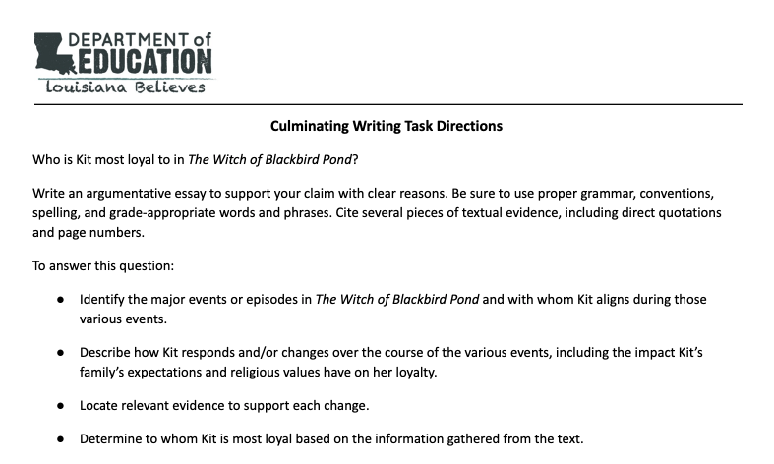

Knowledge | Skills

Let’s Set the Context: Reader’s Circle for Literary Texts

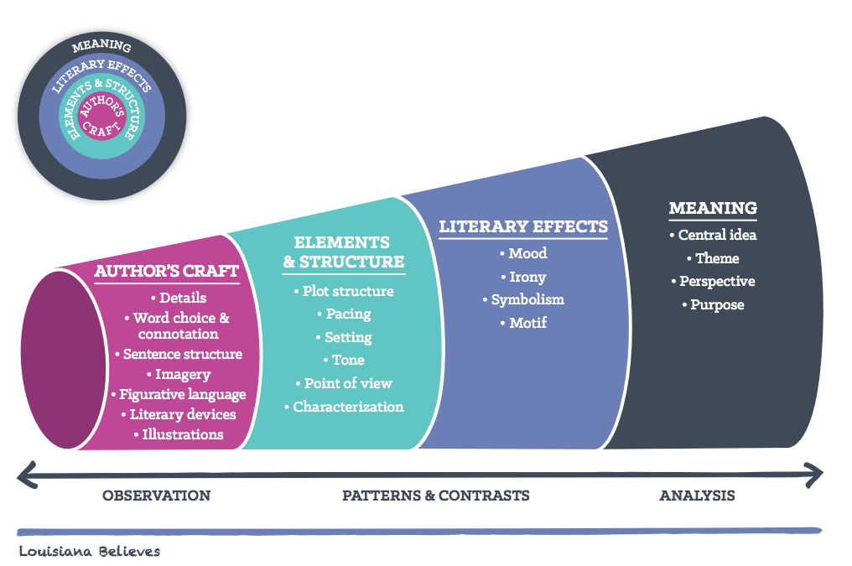
Reflection and Closing
What did you learn from the scoring activity?

